**ASSIGENMENT :2 – BUILD JOB BY USING JENKINS WEBHOOK TRIGGER ……………….**

-----------------------------------------------------------------------------------------------------------------------------------------------------------------------------------------

FIRST CREATE JENKINS MASTER-SERVER AND INSTALLATION OF …..

1. **JAVA : openjdk 11.0.23 2024-04-16 LTS**

#yum install java-11-amazon-corretto.x86_64

1. **GIT : git version 2.40.1**

# yum install git -y

1. HTTPD : Server version: Apache/2.4.59

#yum install httpd –y

# systemctl start httpd

# systemctl enable httpd

# systemctl status httpd

**# mkdir server**

**# cd server**

**4 ) Apache Tomcat** :wget <https://dlcdn.apache.org/tomcat/tomcat-9/v9.0.89/bin/apache-tomcat-9.0.89.zip>

# unzip apache-tomcat-9.0.89.zip

# rm -rf apache-tomcat-9.0.89.zip

# chmod -R 777 apache-tomcat-9.0.89/

# cd apache-tomcat-9.0.89/

**5 ) Install jenkins by using .war file**

# cd webapps/

# wget https://get.jenkins.io/war-stable/latest/jenkins.war

# ls -ltr

# cd ..

# cd bin

# ./startup.sh

**THIS DASHBOARD SHOW ALL JOBS BUILD HISTORY…..**

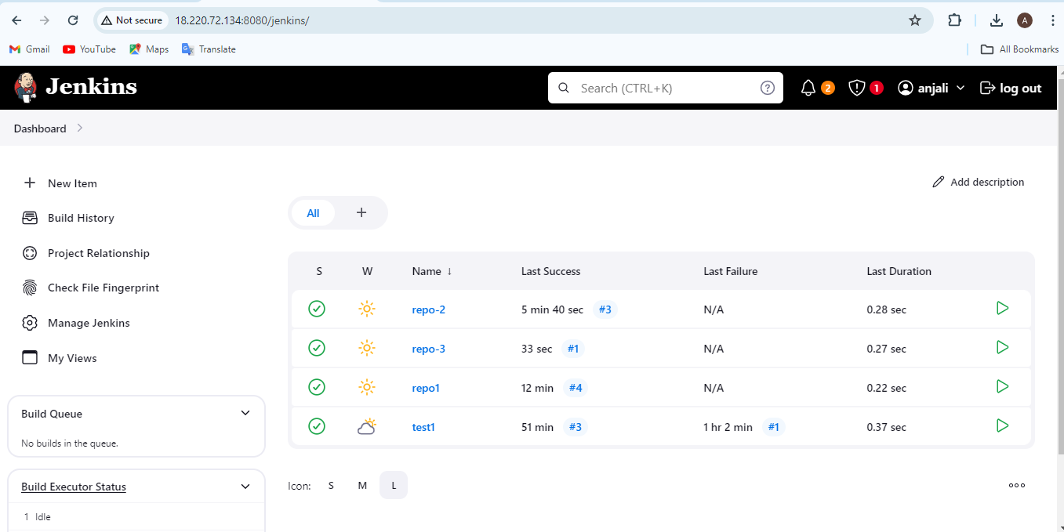

---------------------------------------------------------------------------------------------------------------------------------------------------------------------------------

**After install and setup >>> go Jenkins dashboard & configer JOB as fallow :**

**First create job : REPO-1**

Execute shell…..

chmod –R 777 /var/www/html/

cd /var/www/html/

rm -rf *

cp –r /root/.jenkins/workspace/repo1/index.html .

chmod -R 777 index.html

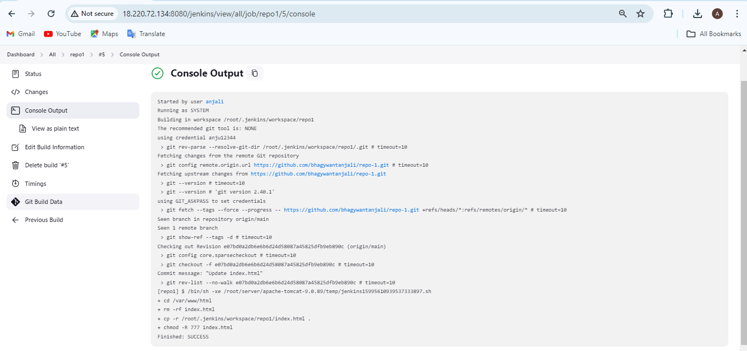

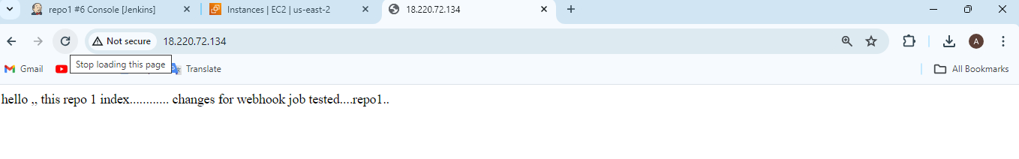

**==============================================================================================================**

**second create job : REPO-2**

Execute shell…..

chmod –R 777 /var/www/html/

cd /var/www/html/

rm -rf *

cp –r /root/.jenkins/workspace/repo-2/index.html .

chmod -R 777 index.html

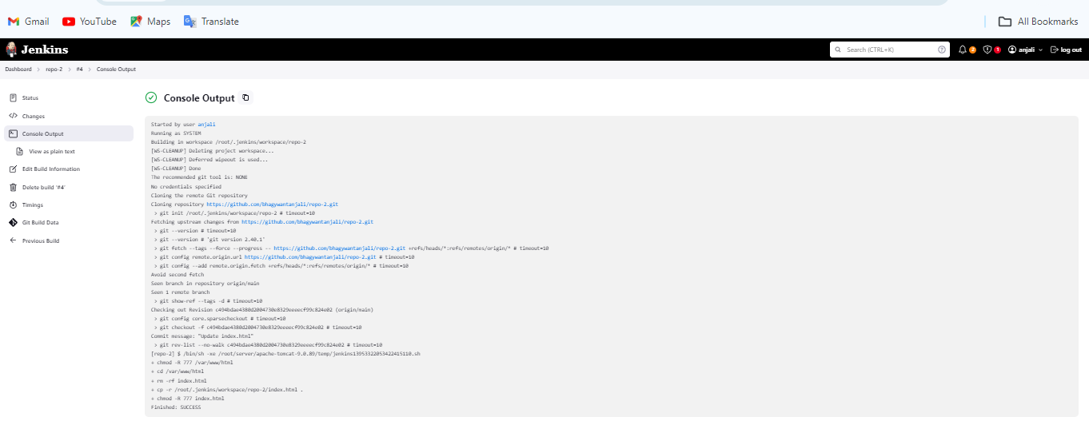

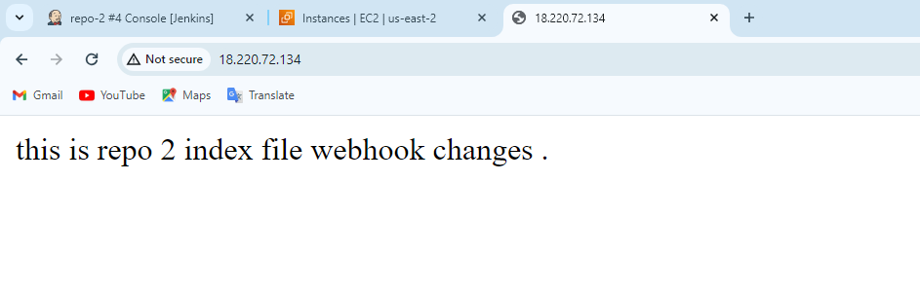

====================================================================================================================================

**third-create job : REPO-3**

Execute shell…..

chmod –R 777 /var/www/html/

cd /var/www/html/

rm -rf *

cp –r /root/.jenkins/workspace/repo-3/index.html .

chmod -R 777 index.html

